Date: December 2025
To: Haylee Kempf, Portfolio Sales & Marketing
From: Tatianna Scavella, Portfolio Sales and Marketing Manager
Re: The Union 30-Day PSM Support Plan
_______________________________________________________________________________________________________

INTRODUCTION:
The purpose of this 30-day plan is to provide intensive, hands-on support for The Union's on-site team, focusing on strategic leadership, leasing consistency, and the establishment of an intentional digital marketing presence. This plan is designed to address the Community Manager's leasing and marketing training needs by implementing clear, daily, and weekly leasing procedures and accelerating marketing efforts to capitalize on the current leasing season.

CORE OBJECTIVES:
- Leasing Team Alignment: Establish and enforce a consistent weekly/daily leasing strategy with clear metrics and accountability.
- Strategic Communication: Execute four targeted outreach e-blast campaigns to drive traffic/applications/renewals.
- Digital Presence Consistency: Audit and implement a cohesive strategy for social media, review collection, and physical outreach.
- CM Development: Provide hands-on coaching and resources for the CM to be able to create an effective leasing strategy, lead the leasing team in executing said strategy, and drive leasing velocity using social media, outreach marketing, and review campaigns.

JANUARY 2026 LEASING NEEDS:
Historically, January is a slower leasing month for The Union – capturing slightly more new leases than renewals. The strategy below emphasizes the need to capture more renewals and new lease traffic over the course of 30 days.
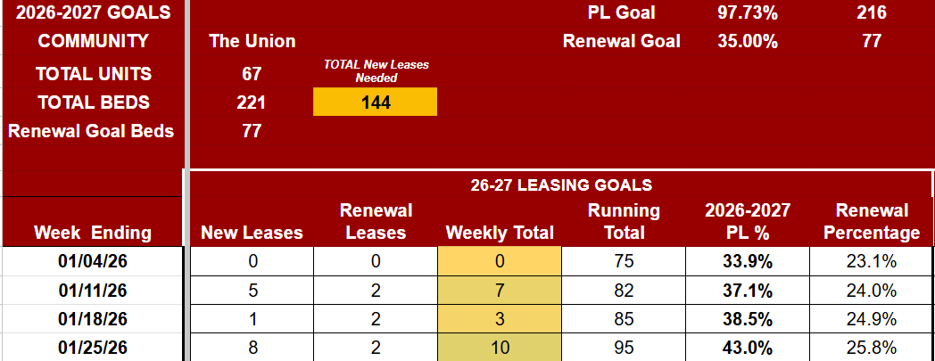
- January 2026 EOM Goal: 43% - 95 total leases
- Historical January EOM Data:
  - Prelease: 41.18% - 91 total leases
    - Renewals: 61 total renewals
    - New Leases: 30 total new leases
- Variance to Goal:
  - Renewals: -14
  - New Leases: -28

30-DAY SUPPORT PLAN:
The plan is divided into four distinct weeks, each with a focused theme and specific deliverables.
Week | Key PSM Deliverables | CM/Leasing Team Focus (Directed by PSM)
Week 1  01.05 - 01.09  PSM PTO -  01.05 & 01.06  PSM Catch Up Day -  01.07 (offline to team)  Fully Back Online -  01.08 | - Weekly Plan Template: Create and release a required Weekly Leasing Strategy (WLS) Document to be completed by the CM.  - Will be due on Fridays to PM & PSM.  - Social Media Calendar: Finalize new social media content calendar and posting guidelines.  - Outreach E-blast 1: Release targeted e-blast for Non-Renewed Residents and GUAs | - CM - Implements daily Top of Shift Pow Wow (15 minute huddles) expectation to download the leasing team on their priority and tasks for the day.  1. Renewal Offer regeneration  - Leasing Team –  1. January non-renewed GUA call bank due 01.06.2026 and non-renewed resident call bank due 01.10.2026  2. OSU Outreach Marketing at least 2x/wk.  3. Daily new lease follow-up
Week 2  01.12 - 01.16 | - Follow-Up Audit: Review current follow-up cadence compliance  - CM Coaching: One-on-one session to review WLS requirements, leading daily huddles, and holding the team accountable to accomplish assigned tasks.  - Outreach E-blast 2: Release targeted e-blast for Current and Archived Prospect list w/ Tour and Score | - CM leads Top of Shift Pow Wow on strategy/goals and sends daily 5@5 w/ updates on leasing progress.  1. Renewal offer regeneration  - Leasing Team –  1. January non-renewed walks due 01.17.2026  2. OSU Outreach Marketing at least 2x/wk.  3. Social Media content  4.Collect 1 new review this week.  5. Daily new lease follow-up
Week 3  01.19 - 01.23 | - Inquire about Spring Housing Fair and on-campus event opportunities  - Leasing Strategy & Text Campaign: Provide leasing team with texting templates to complete non-renewed text bank  - Outreach E-blast 3: Release floor plan specific e-blast encouraging with limited availability push. | - CM leads Top of Shift Pow Wow on strategy/goals and sends daily 5@5 w/ updates on leasing progress.  1. Renewal offer regeneration  2. CM submits WLS for review  - Leasing Team –  1. Collect 2 New Reviews this week.  2. January non-renewed text campaign due 01.24.2026  3. OSU Outreach Marketing at least 2x/wk.  4. Social Media content  5. Daily new lease follow-up
Week 4  01.26 - 01.30 | - CM Handoff: Review all new processes (Reporting, Huddles, Marketing) and verify CM comfort/competence.  - Outreach E-blast 4: Release e-blast focused on Limited Availability/Rate Increase Warning. | - CM leads Top of Shift Pow Wow on strategy/goals and sends daily 5@5 w/ updates on leasing progress.  1. CM independently releases the WLS to the team.  2. Renewal offer regeneration  - Leasing Team –  1. Full pending lease deep dove and follow-up  2. Collect 2 New Reviews this week.  3. OSU Outreach Marketing at least 2x/wk.  4. Social Media content

STRATEGIC OUTREACH EBLAST CADENCE:

Week | Audience | Purpose & Intent
Week 1 | Non-Renewed Residents | Urgency & Retention: Drive immediate non-renewal lease signings with an exclusive, expiring offer.
Week 2 | Proactive Prospect List | Value Proposition: Drive tours and applications by highlighting the value proposition and current competitive rates/specials.
Week 3 | Stale Leads/Specific Floor plan Focus | Micro-Targeting: Clear out a specific floor plan or address a dip in traffic with a limited-time incentive.
Week 4 | Low Hanging Fruit | Scarcity & Action: Create urgency before a rate increase or the closure of a popular floor plan/special.

MARKETING & REVIEW STRATEGY:
I will personally oversee the launch of the following to ensure a cohesive digital front:
- Social Media: Develop a 30-Day Content Matrix focusing on intentional, engaging, and consistent posts that directly support the weekly leasing focus,
  - EX: If Week 2’s focus is on Reno apartments, the social content highlights that.
- Outreach Marketing: Establish a clear expectation for on-campus outreach to drive prospects back to the community to tour and application.
- Review Collection: Standardize the process to request reviews at key points (e.g., immediately after a positive tour, upon lease signing) to increase the property's overall star rating and quantity of recent reviews.

SPECIAL PROPOSAL:
By 12.26.2025, a tour and score incentive will be rolled up for approval to help increase new lease velocity for January’s leasing goals.

